Example 2:

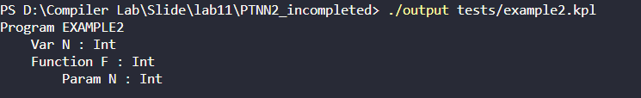

Example 3:

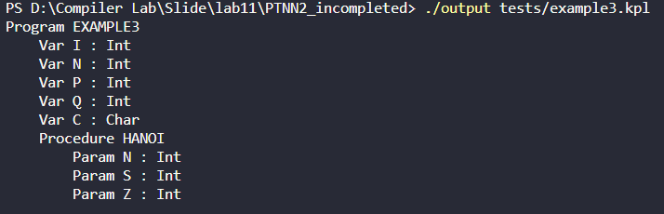

Example 4:

